Housing: Resale Value Prediction Model
Pankaj K Yadav
Bellevue University

Table of Contents
Introduction: 3
Data Acquisition and Source 3
Organized Summary of Milestones 1-3 3
Milestone 1: EDA and Business Framing 3
Milestone 2: Data Preparation 4
Milestone 3: Modeling and Evaluation 4
EDA Highlights (include visuals in notebook/PDF) Error! Bookmark not defined.
Data Cleaning and Preprocessing Summary 6
Modeling, Evaluation and Interpretation 7
Content Added Since Milestone 3 7
Conclusion 7
Is the model ready for deployment? 7
Recommendations 7
Remaining challenges and opportunities 8

Introduction:
This project aims to empower real estate investors in Ames, Iowa, with a predictive analytics tool for estimating home sale prices and optimizing renovation investments. The objective is to provide actionable insights that maximize return on investment (ROI) for property renovations, reduce cost overruns, and improve acquisition decisions. The project scope covers data acquisition, analysis, modeling, and deployment of a machine learning solution.
Residential real estate investors must decide which properties to buy, and which renovations will create the greatest value at resale. Without a data-driven system, firms may overinvest in low-impact upgrades, underinvest in high-impact improvements, or misprice acquisitions.
This project addresses that problem by building a predictive model of home sale price using property and quality features from the Ames Housing dataset. The model is intended to support renovation planning, valuation, and acquisition decisions for a real estate investment business operating in Ames, Iowa.
This problem is important because pricing errors directly affect profit margins, project timelines, and capital allocation. A practical prediction model can help stakeholders reduce risk, prioritize renovations, and improve return on investment.
If presented to leadership, the business case is straightforward:
- Improve pricing accuracy before purchase.
- Prioritize renovations with measurable value impact.
- Reduce unnecessary scope and budget overruns.
- Increase confidence in go/no-go acquisition decisions.
The model serves as a decision-support tool, not a replacement for field expertise. It provides objective, repeatable, and auditable valuation guidance.

Data Acquisition and Source
The project uses the Ames Housing data from Kaggle:
House Prices: Advanced Regression Techniques
https://www.kaggle.com/competitions/house-prices-advanced-regression-techniques/data
- train.csv was used for model development and validation.
- test.csv was used for feature engineering consistency and deployment-style readiness.
The dataset is appropriate because it includes structural, quality, and neighborhood variables strongly related to residential sale price.

Organized Summary of Milestones 1-3

Milestone 1: EDA and Business Framing
- Defined the business objective: predict Sale Price and identify value-driving renovation levers.
- Performed initial profiling: shape, data types, missing, duplicates.
- Conducted visual EDA:
  - Sale price distribution (right skewed).
  - Quality vs. sale price (strong positive relationship).
  - Renovation linked variables (living area, garage, basement, kitchen quality).
- Added domain level derived features:
  - TotalSF, Age, YearsSinceRemod, TotalBathrooms,
  - Amenity flags like HasPool, HasGarage, HasBasement & HasFireplace
  - QualityIndex.

Milestone 2: Data Preparation
- Removed low-value, high-missing, and near constant features with clear justification.
- Added additional engineered features:
  - GarageScore, BsmtFinishedPct, AvgRoomSize, LotUtilization.
- Performed train/test split before data-dependent transformations to reduce leakage risk.
- Applied log transformation to high-skew predictors and target (SalePrice).
- Imputed missing values with domain-aware logic plus train-derived fallback median/mode.
- One-hot encoded categorical variables and aligned train/test columns.
- Standardized features with StandardScaler fit on train only.
- Ran diagnostics:
  - Multicollinearity checks.
  - Outlier screening via Z-scores.

Milestone 3: Modeling and Evaluation
- Built and compared:
  - DummyRegressor (baseline),
  - LinearRegression,
  - Ridge Regression (alpha tuning),
  - RandomForestRegressor (tree-count tuning).
- Selected best model by test RMSE and generalization behavior.
- Best-performing model: Ridge Regression.
- Reported final performance:
  - Test RMSE (log scale): 0.132
  - Test R²: 0.89

EDA Highlights and Visualizations
The exploratory phase produced several key visualizations that inform both technical understanding and business strategy. A histogram of sale prices in the original (non-transformed) scale illustrated the pronounced right skew, with the bulk of the market centered below $250,000 and a long tail of luxury properties extending to $750,000 (Plot 1). This visualization motivated log transformation and informed market segmentation strategy.

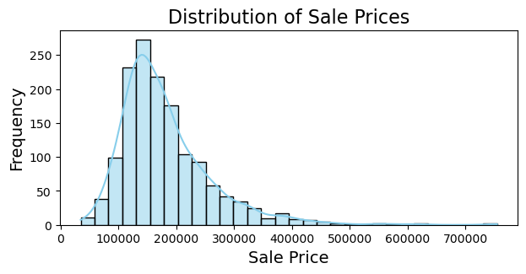
Plot1. Sale price distribution histogram.
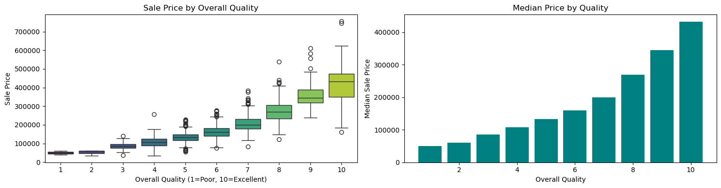
Plot 2. Overall quality vs. sale price (box/bar plots).
A four-panel grid (Plot 3) showcased key renovatable features. A scatter plot of gross living area versus sale price, colored by quality, illustrated how living area and quality interact to drive price. A box plot of garage capacity revealed discrete price jumps at each car-count level. A violin plot of basement size categories showed the price distribution widening with basement size. A bar chart of kitchen quality displayed distinct median price differences across the four quality levels. Together, these visualizations quantified the ROI potential of targeted renovations.
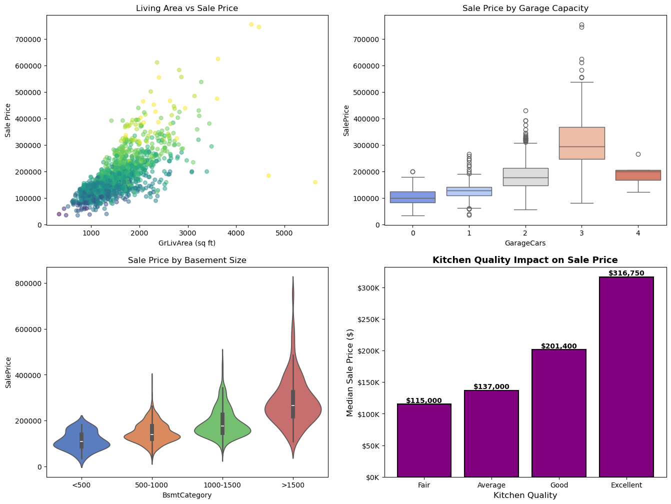
Plot 3. Renovatable feature impact charts.
A model comparison bar chart (Plot4.) ranked algorithms by test RMSE, visually demonstrating Ridge Regression's superior performance. A final 2x2 residual diagnostic panel (Plot 5.) comprising residuals-versus-predicted, histogram, Q-Q plot, and residuals-over-index plots provided comprehensive validation of modeling assumptions.
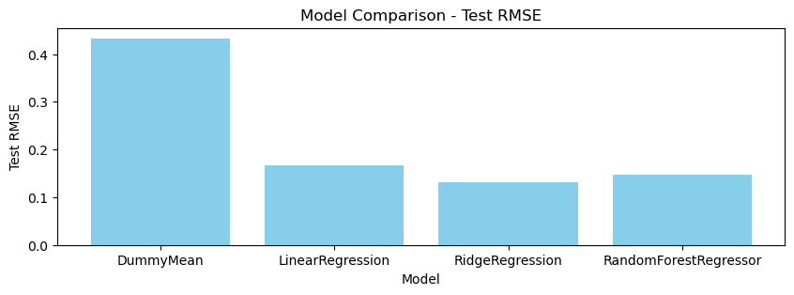
Plot 4. Model comparison bar chart (test RMSE).
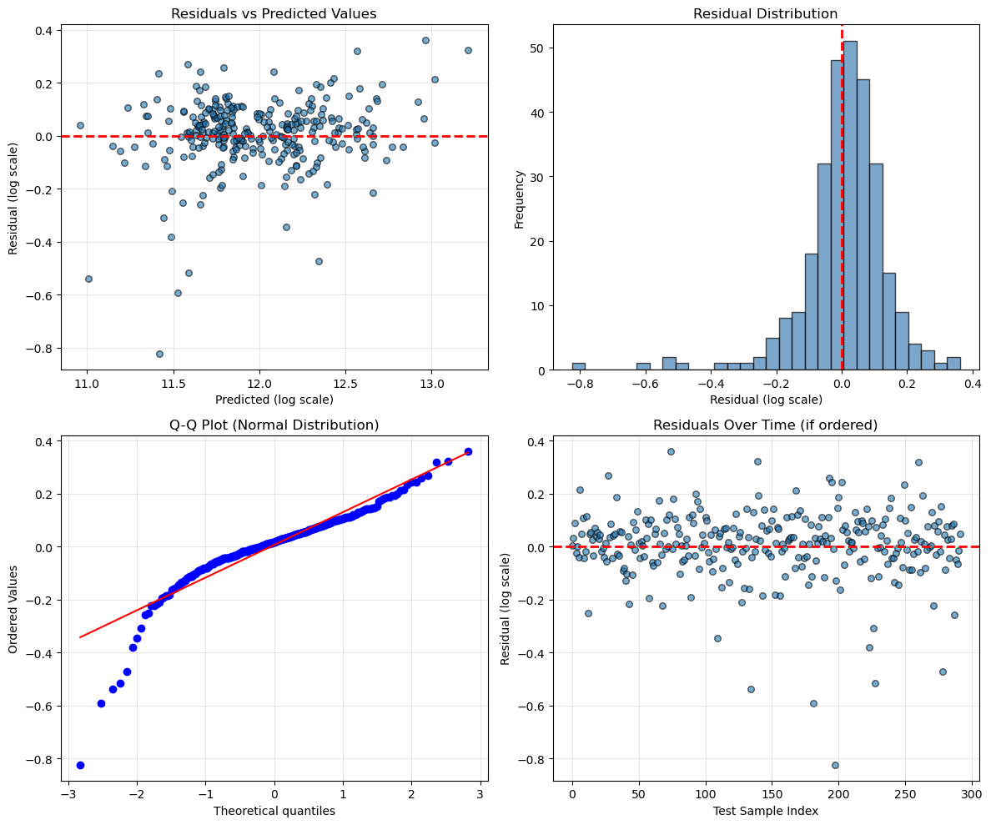
Plot 5. Residual diagnostics panel for selected model.
These visuals support both technical validation and business interpretation.

Data Cleaning and Preprocessing Summary
- Missing data handled with business semantics where possible (feature absence vs. unknown).
- High-missing and low-information columns removed to reduce noise.
- Skewed features transformed to improve linear model fit.
- Categorical encoding and scaling performed with train-first methodology.
- Quality checks completed for redundancy and outliers.
This process produced a clean, model-ready dataset with controlled leakage risk.

Modeling, Evaluation and Interpretation
The model comparison showed that Ridge Regression outperformed baseline and non-regularized linear models and generalized better than Random Forest on this transformed feature space.
Residual diagnostics for Ridge indicated:
- Mean residual near zero (low bias),
- No clear residual-pattern trend (supports constant variance),
- Some tail deviation from normality (common in housing data with outliers).
Interpretation: the model is reliable for typical market properties, with more caution needed at extremes.

Content Added Since Milestone 3
The following updates were added after Milestone 3 and are explicitly included in this final submission:
- Model selection correction: Finalized Ridge Regression as best model based on test RMSE and generalization gap.
- Residual diagnostics expansion: Added 2x2 residual plot panel and Shapiro-Wilk normality check.
- Narrative correction: Updated prior summary language that incorrectly emphasized Random Forest.
- Final business interpretation update: Aligned conclusions to Ridge-based results and deployment guidance.
- Final write-up integration: Consolidated Milestones 1-3 plus updates into one coherent final report.

Conclusion
This project produced a robust, interpretable home-price prediction framework for renovation-focused real estate investing in Ames, Iowa. The Ridge Regression model achieved strong predictive performance (RMSE 0.132 log scale, R² 0.89) and offers practical value for acquisition and renovation planning.

Is the model ready for deployment?
Conditionally yes. It is suitable as a decision-support tool for typical properties, especially within common market ranges. It should be paired with human review for edge cases and luxury outliers.

Recommendations
- Use Ridge predictions as baseline valuation inputs in underwriting workflows.
- Continue periodic retraining with newer market data.
- Add monitoring for prediction drift and outlier behavior.
- Build a simple dashboard/API for analyst use and scenario testing.

Remaining challenges and opportunities
- Limited representation of extreme-price homes may reduce reliability in tails.
- External macroeconomic signals are not yet included..
Repository: https://github.com/pankajsyadav/DataMining.git

